Lesson 03 Demo 04

Creating a Shared Access Signature

Objective: To create a shared access signature to access storage account

Tools Required: None

Prerequisites: A storage account

Steps to be followed:
- Create a shared access signature (SAS) at the service level
- Create a shared access signature (SAS) at the account level

Step 1: Create an SAS at the service level

  - Locate the storage account you want to work on and open it

  - Drill down to the blob container

  - Click on the file you want to provide access to

  - Right-click and select the Generate SAS tab

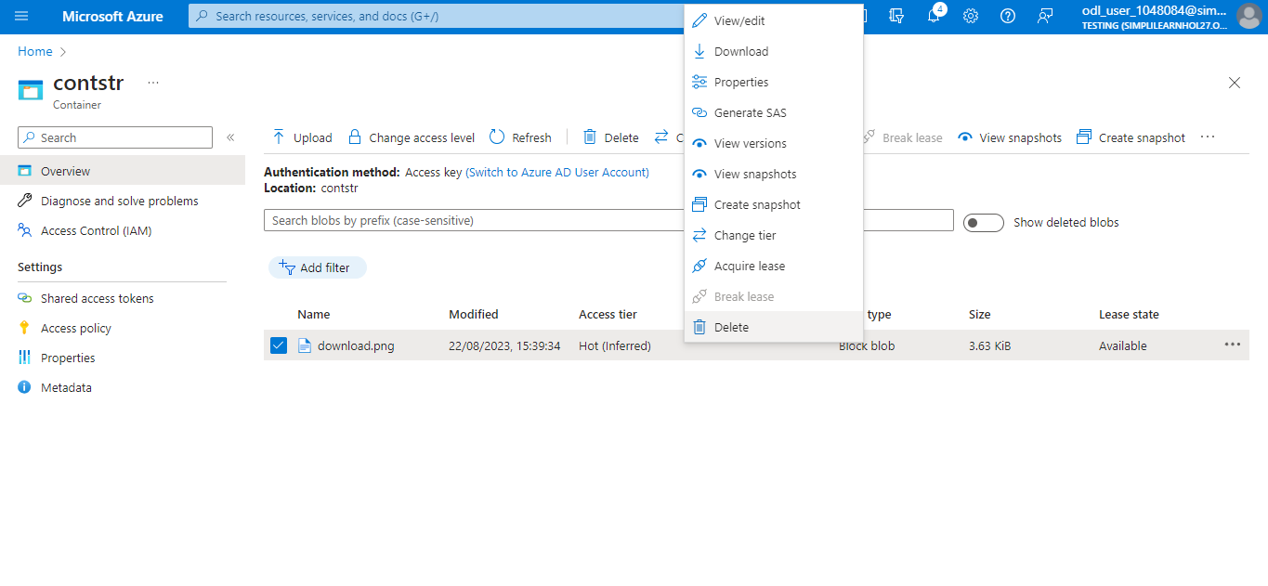

  - Configure the shared access signature using the following parameters:
Signing key: Key1
Permissions: Read
Start and expiry date/time: Today's date to start, 1 year out for expiry
Allowed protocols: HTTPS
After selecting the parameter, click on Generate SAS token and URL to continue
with the next step

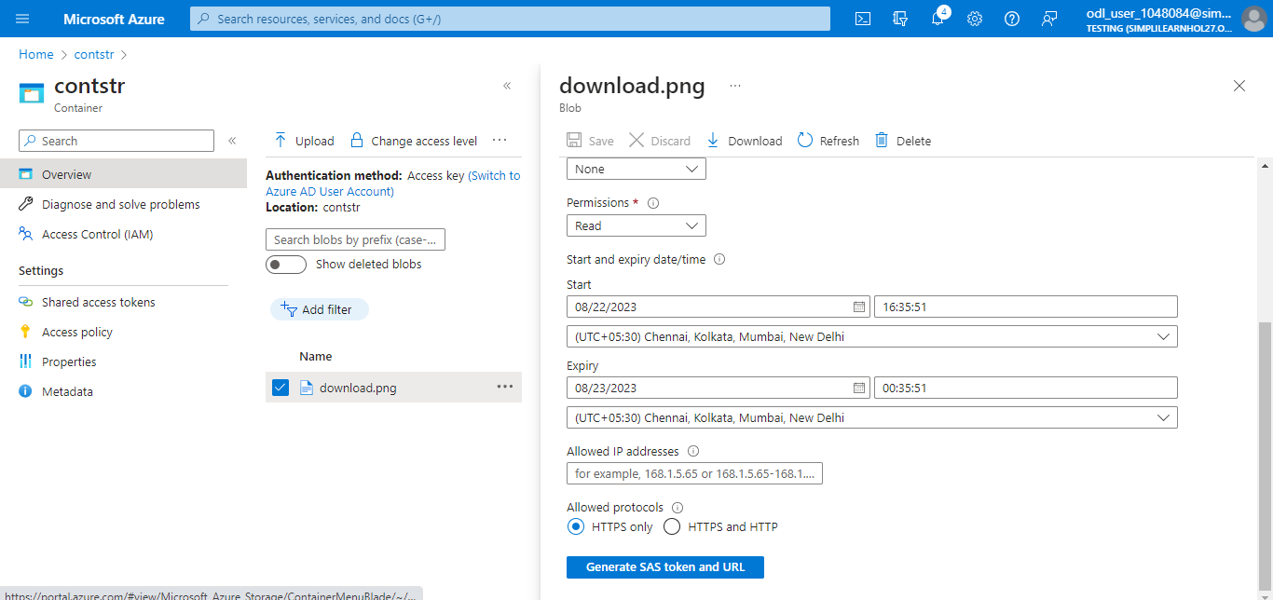

  - Copy the Blob Server SAS URL and paste the URL into a browser. Verify the blob files to display.

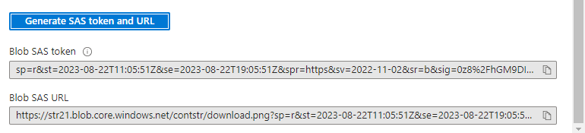

Step 2: Create an SAS at the account level

  - Return to the storage account

  - Under Security + networking, select Shared access signature

  - Configure a variety of services, resource types, and permissions

  - Click Generate SAS and connection string by selecting the required services and permissions

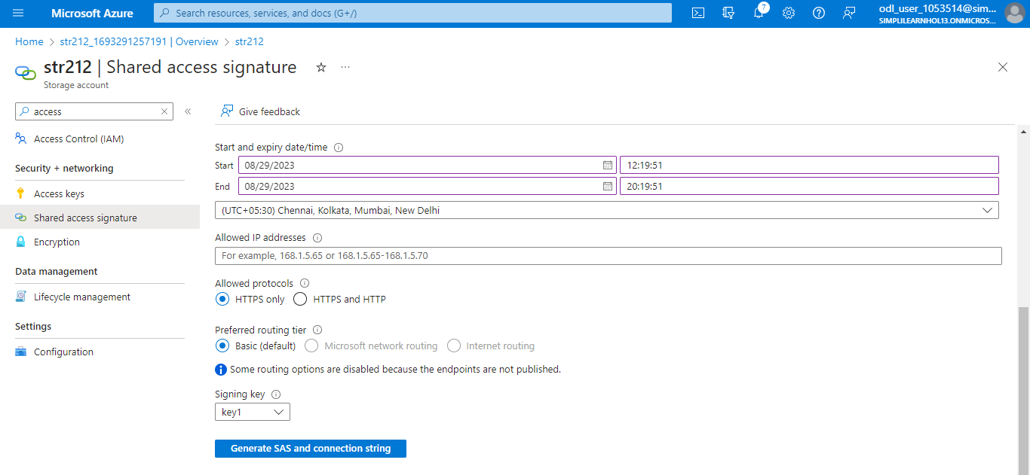

The output will be as shown below:

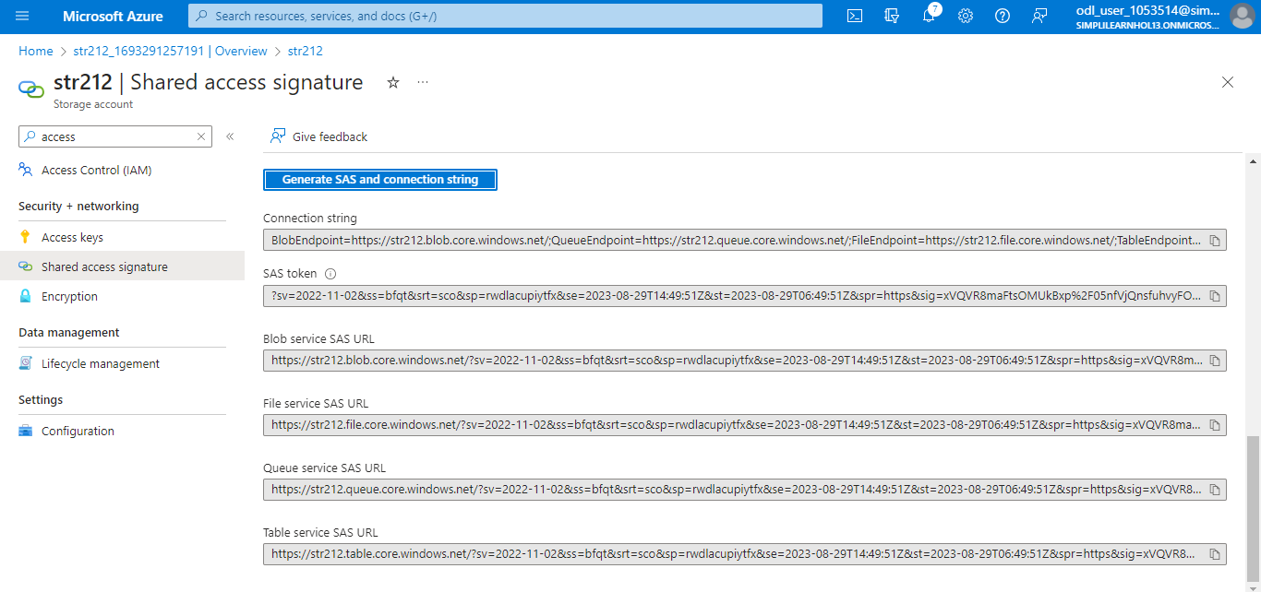

You have now successfully created the shared access signature to access your
storage account or any individual data inside the storage account.

